1.FCFS
#include <stdio.h>
int main()
{
int n, i;

printf("Enter total number of processes: ");
scanf("%d", &n);

int at[n], bt[n], ct[n], tat[n], wt[n];

// Input
for(i = 0; i < n; i++)
{
printf("\nProcess [%d]\n", i+1);

printf("Arrival time: ");
scanf("%d", &at[i]);

printf("Burst time: ");
scanf("%d", &bt[i]);
}

int current_time = 0;

// FCFS Calculation
for(i = 0; i < n; i++)
{
if(current_time < at[i])
current_time = at[i];

ct[i] = current_time + bt[i];
tat[i] = ct[i] - at[i];
wt[i] = tat[i] - bt[i];

current_time = ct[i];
}

float avg_tat = 0, avg_wt = 0;

// Output Table
printf("\nProcess Arrival Time Burst Time Completion Time Turnaround Time Waiting Time\n");

for(i = 0; i < n; i++)
{
printf("%d\t%d\t%d\t%d\t\t%d\t\t%d\n",
i+1, at[i], bt[i], ct[i], tat[i], wt[i]);

avg_tat += tat[i];
avg_wt += wt[i];
}

avg_tat /= n;
avg_wt /= n;

printf("\nAverage Turnaround Time: %.2f", avg_tat);
printf("\nAverage Waiting Time: %.2f\n", avg_wt);

return 0;
}
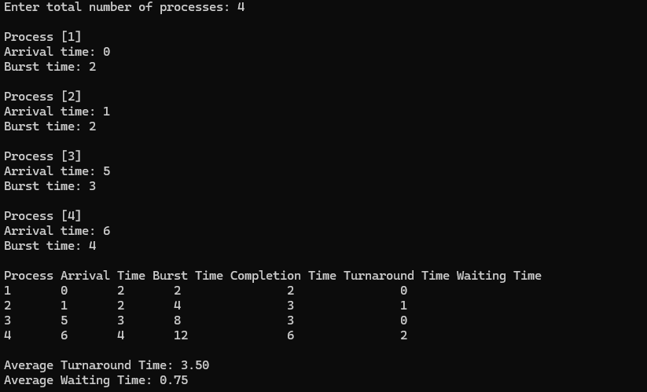

2.SJF Non Pre-emptive

#include <stdio.h>

int main()
{
int n, i, j;
printf("USN: 1WA24CS198");
printf("\nEnter number of processes: ");
scanf("%d", &n);

int at[n], bt[n], ct[n], tat[n], wt[n];
int finished[n];

for(i = 0; i < n; i++)
finished[i] = 0;

printf("Enter arrival times:\n");
for(i = 0; i < n; i++)
scanf("%d", &at[i]);

printf("Enter burst times:\n");
for(i = 0; i < n; i++)
scanf("%d", &bt[i]);

int current_time = 0, completed = 0;
int min_index;

while(completed < n)
{
min_index = -1;
int min_bt = 10000;

for(i = 0; i < n; i++)
{
if(at[i] <= current_time && finished[i] == 0)
{
if(bt[i] < min_bt)
{
min_bt = bt[i];
min_index = i;
}
}
}

if(min_index == -1)
{
current_time++;
}
else
{
ct[min_index] = current_time + bt[min_index];
tat[min_index] = ct[min_index] - at[min_index];
wt[min_index] = tat[min_index] - bt[min_index];

current_time = ct[min_index];
finished[min_index] = 1;
completed++;
}
}

float avg_tat = 0, avg_wt = 0;

printf("\nSJF scheduling:\n");
printf("PID\tAT\tBT\tCT\tTAT\tWT\n");

for(i = 0; i < n; i++)
{
printf("P%d\t%d\t%d\t%d\t%d\t%d\n",
i+1, at[i], bt[i], ct[i], tat[i], wt[i]);

avg_tat += tat[i];
avg_wt += wt[i];
}

avg_tat /= n;
avg_wt /= n;

printf("\nAverage turnaround time:%fms\n", avg_tat);
printf("\nAverage waiting time:%fms\n", avg_wt);

return 0;
}

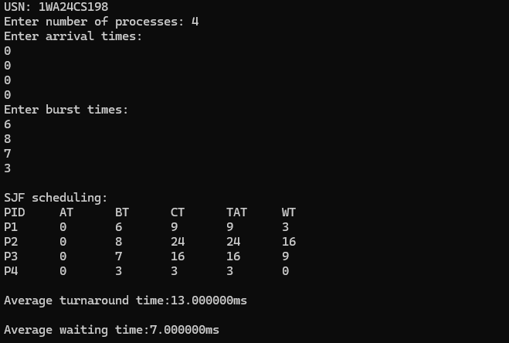

3.SRTF

#include <stdio.h>

int main()
{
int n, i, time = 0, completed = 0, min_index;
printf("USN: 1WA24CS198");
printf("\nEnter the number of processes: ");
scanf("%d", &n);

int at[n], bt[n], rt[n], ct[n], tat[n], wt[n];

for(i = 0; i < n; i++)
{
printf("Enter arrival time and burst time for process %d: ", i+1);
scanf("%d %d", &at[i], &bt[i]);
rt[i] = bt[i]; // remaining time
}

while(completed < n)
{
min_index = -1;
int min_rt = 10000;

for(i = 0; i < n; i++)
{
if(at[i] <= time && rt[i] > 0)
{
if(rt[i] < min_rt)
{
min_rt = rt[i];
min_index = i;
}
}
}

if(min_index == -1)
{
time++;
}
else
{
rt[min_index]--;
time++;

if(rt[min_index] == 0)
{
completed++;
ct[min_index] = time;
tat[min_index] = ct[min_index] - at[min_index];
wt[min_index] = tat[min_index] - bt[min_index];
}
}
}

float avg_wt = 0, avg_tat = 0;

printf("\nPID\tAT\tBT\tCT\tTAT\tWT\n");

for(i = 0; i < n; i++)
{
printf("%d\t%d\t%d\t%d\t%d\t%d\n",
i+1, at[i], bt[i], ct[i], tat[i], wt[i]);

avg_wt += wt[i];
avg_tat += tat[i];
}

avg_wt /= n;
avg_tat /= n;

printf("\nAverage Waiting Time: %.2f\n", avg_wt);
printf("Average Turnaround Time: %.2f\n", avg_tat);

return 0;
}

